C219 Front-end Web Development

**Lesson 10**

Worksheet

Introduction to Infographics

1. What is an infographic? Search for a good example and link to the image here.

An infographic is a collection of imagery, data visualizations like pie charts and bar graphs, and minimal text that gives an easy-to-understand overview of a topic.  
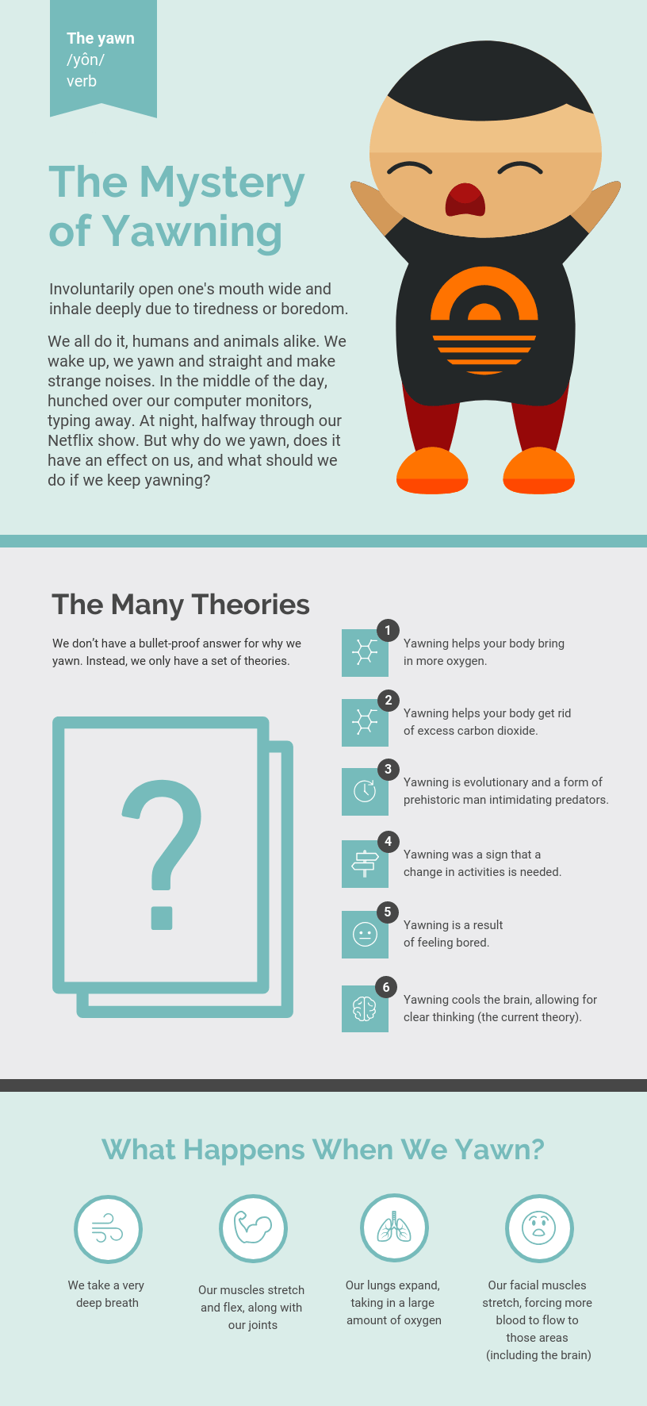

1. Explain the differences and advantages of an interactive infographic compared to traditional infographics. Provide a link to a good example of an interactive infographic.

An interactive infographic allows the audience to click or drag specific elements of the image and it is the most interesting type of infographic as it makes it possible to use several features at the same material. It also gives the audience full control of how the content will be consumed. This, however, means that some viewers may skip over parts they do not find interesting and thus, they will miss out on information that they didn’t read.

A traditional infographic does not allow the audience to click or drag specific elements- it is just an infographic without the interactivity. But a traditional infographic doesn’t allow users to skip over anything since it is all in one page, and no information will be hidden, unlike an interactive infographic where some data may be hidden, left for the user to explore and discover what data could be in the infographic.

An example: <http://view.ceros.com/gumgum/the-visual-web/p/1>

Types of Infographics and their Uses

1. Read this [article](https://piktochart.com/blog/8-types-of-infographics-which-right-for-you/) on the types of infographics. List the different types of infographics and their uses in the table below.

|  |  |
| --- | --- |
| **Type of Infographic** | **Uses** |
| Timeline infographic | Ideal type if your goal is to visualise history, plan for an event, highlight a sequence of events, take the audience on a journey, share a story in chronological order, or set the audience’s expectations on how long a process will take |
| Process infographic | Ideal type if your goal is to break down a complex process into easy to digest pieces of information, provide a summary of steps in a process, visualise a procedure. Used for it you want your audience to retain the details of a process or procedure quickly |
| Informational infographic | Ideal type if your goal is to share an overview of a specific topic, introduce a new idea or concept, make a plain blog post or article more engaging for readers. It is a suitable format if you want to present a highly technical subject to an audience who is not familiar with the topic |
| Map infographic | Ideal type if your goal is to illustrate trends on a specific location, share visual stories of a particular place, or to communicate survey results or product statistics based on location. |
| Resume infographic | Ideal type if your goal is to set yourself apart from other candidates and get the hiring manager to call you for an interview, caught the eye of recruiters, leave a remarkable impression, and compel them to learn more about you, showcase specific sections in your resume like certain skills, projects, and teams you’ve worked with |
| List infographic | Ideal type if your goal is to share a collection of tips, support an idea or topic with major points, or summarise your presentation. |
| Data infographic | Ideal type if your goal is to make a case for an argument, opinion, or perspective, or share statistics and make them more impactful. These types of infographics are very versatile. |
| Comparison infographic | Ideal type if your goal is to encourage the audience to see two or multiple perspectives, compare pros and cons or to show similarities and/or differences |
| Flowchart infographic | Ideal type if your goal is to simplify workflows, present solutions, brainstorm ideas, visualise chain of command, share possible scenarios or consequences, or to describe processes with multiple paths clearly and concisely |
| Interactive infographic | Ideal type if your goal is to allow audiences to uncover new information, explore the infographic based on their interest, or increase the time spent from your audience on your infographic. Often used in data visualisation and content which employs gamification |

Interactive Infographics Guidelines

1. Refer to these websites on guidelines for creating interactive infographics:
   * [Website 1](https://www.creativebloq.com/infographic/8-pro-tips-creating-interactive-infographics-11133560)
   * [Website 2](https://rockcontent.com/blog/interactive-infographic/)
   * [Website 3](https://sachsmarketinggroup.com/8-tips-for-interactive-infographics/)

List the key guidelines gathered from the references above and describe what they mean in the table below.

|  |  |
| --- | --- |
| **Guidelines** | **Description** |
| scrolling effects | Scrolling usually triggers animations and transitions, and users will feel compelled to finish what they started. It is great for drawing users into a story and making them feel more engaging without over taxing any limit of interest |
| Allow users to highlight certain areas | Interactive highlighting can help minimise initial confusion, which is essential for attracting and retaining the attention for users |
| Hide some information | Allows users to actively participate in the infographic, so they have to click or do rollovers before being able to access more information. Allows them to skip over topics which disinterests them without discouraging them from continuing on with the rest of the infographic |
| Define your goals | Think about what you want to accomplish with this, define your persona, decide on what problems to address, how you can help, and what platform your infographic will run |
| Keep it short and simple | Have a concise and engaging format, as long texts are not meant for content such as these |
| Avoid content which requires zoom in to read | Makes the readers experience uncomfortable and unpractical- ensure that the content is readable without zooming in on the image |
| Use storytelling | Establishes a deeper connection with the audience. Set up an overall narrative and organise your subtopics, making it possible to leader your readers through a visual path |
| Strive for accuracy | Present accurate information to ensure credibility and prevent the spread of false information |
| Ensure page responsivity | Audiences may use different forms of devices to access content, so make sure the page will work will no matter the screensize |
| Use different font styles | There should be a textual hierarchy composed of at least 3 different font styles, as the text determines the level of importance of each piece of information |
| Use visual elements to indicate the ideal path to read the content | Indicate ideal path to read it with lines, shapes, borders, different colours etc |
| Proofread, edit and test | Ensure there are no mistakes so that the audience will be able to enjoy the infographic as a great piece of content |

 **Solving the Problem**

1. Based on the types of infographics listed in question 3, which ones can you apply for your interactive infographic website? Explain with reference to the parts of your website.  
   Data infographic – first section, for a chart displaying daily covid-19 cases in Singapore for the past month

Informational infographic – first section, for information about the number of covid-19 cases in Singapore; second section, for information about the vaccination progress in Singapore

Map infographic – third section, for a map containing locations of vaccination centres in Singapore

List infographic – third section, for an interactive table containing a list of vaccination centres in Singapore

1. So far, you have learned and applied CSS frameworks and JavaScript libraries such as Bootstrap, jQuery, Anime.js and Chart.js. What are the frameworks and libraries you plan to apply for your assignment today? Explain in detail.

Fullpage.js, Bootstrap, jQuery, Anime.js, tippy.js and Chart.js. Fullpage.js is for the single-page requirement, bootstrap is for the navigation bar, anime.js is for the animations, chart.js is for the information regarding cases or vaccination progress (planning to show the details in bar/pie charts if possible, bar for cases, pie for vaccination progress), tippy.js is for the map containing locations of different vaccination centres in Singapore (tooltip on hover over dots, wherein the dots are to show the location of vaccination centres)

1. List a few effective interactive infographic websites to refer to for inspiration for your assignment. Provide reasons for your choices. You can list as many websites as you like.

|  |  |
| --- | --- |
| **Websites** | **Reasons** |
| <https://lemonly.com/l/marriott/family-fun-in-scottsdale/index.html> | By tapping on different buttons, different choices or routes will appear. It captures the viewers attention and they will be curious/compelled to explore everything by seeing all the potential different choices, or just selecting the choices that they want to see. The graphics are also simplistic and appealing to the eye |
| <https://www.washington.edu/news/2021/01/27/moon-sleep/> | Hovering on different points in the sleep duration, sleep start, or the circle in between the different moon shapes will highlight different information, which will being the user’s attention to the information being display and make them focus on it |
| <https://www.cbiz.com/insights/main-street-index> | After loading in, there is an animation displaying the different bars popping up in the charts. When hovering over different charts, more information will also be displayed. Scrolling down loads more charts and various animations will be played upon loading in |

1. Design a low-fidelity wireframe for your interactive infographic and attach it below (image or XD link):

|  |
| --- |
| <https://xd.adobe.com/view/c5aba696-98fd-4d90-a6eb-d3200dabf709-90f8/> |

** Team Activity**

1. You are to present your worksheet to your team members. Note down comments for your other team members here – include what you feel is effective and the areas where they can improve.

|  |  |
| --- | --- |
| **Team member** | **Comments** |
| Yun Keat | Could have explained more in detail about the frameworks and libraries planned to be used  More types of infographics can be used in the website |
| Izzat | Agree with the usage of infographics, frameworks and js libraries  Contents in the wireframes do not seem to be size consistent |
| Aseerah | Agree with the usage of infographics, frameworks and js libraries  Contents for slide 3 of the wireframe, for map and table could try to use same width to make the website look nicer |
| Qiu Li | Agree with the usage of infographics, frameworks and js libraries  Lofi wireframe could include a bit more details such as the things to be placed in the header, or the items to be used |

 **Deliverables**

Individual submission:

* Worksheet
* L10 Assignment
  + Name your folder L10 Assignment
  + Web page – index.html
  + External stylesheet – style.css
  + External JavaScript – script.js
  + All other assets should be in a folder

**Submit all deliverables by 2359 tomorrow.**